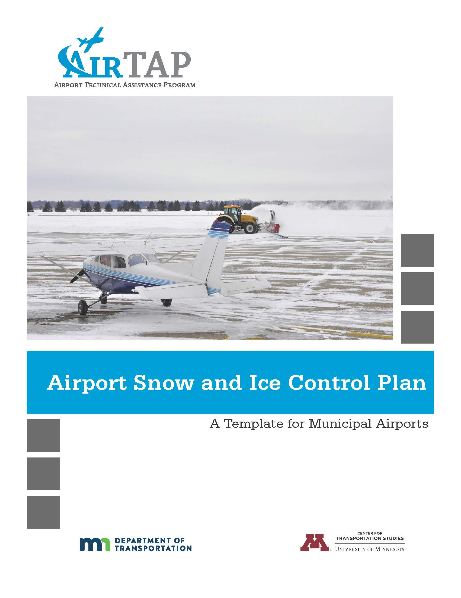

Snow and Ice Control Plan Template
Created for: Office of Aeronautics, Minnesota Department of Transportation
Created by: Ann Johnson, Professional Engineering Services
Published by: Minnesota Airport Technical Assistance Program (AirTAP)
Center for Transportation Studies (CTS)
University of Minnesota
440 University Office Plaza
2221 University Ave. SE
Minneapolis, MN 55414
612-626-1077
www.airtap.umn.edu

Snow and Ice Control Plan (Insert your Airport Name)

Table of Contents
Phase #1 Pre and Post Winter Season Topics Page

1.1 Airport Preparation…………………………………………………………………………………
Airport Management Meeting…………………………………………………………...
Personnel Training……………………………………………………………….……….
Equipment Preparation………………………………………………….……………….
1.2 Snow and Ice Control Meetings…………………………………………………………………..
2.1 Post Event…………………………………………………………………………………………..
2.2 Post Season………………………………………………………………………………….……..

Phase #2 Winter Storm Actions and Procedures

3.1 Activating Snow Removal Personnel……………………………………………….……………
Weather Forecasting……………………………………………………………………..
Chain of Command……………………………………………………………………….
Triggers for Initiating Snow Removal Operations……………………………………..
3.2 Personnel Responsible…………………………………………………………………………….
3.3 Snow Control Center……………………………………………………………………………….
3.4 Airfield Clearing Priorities………………………………………………………………………….
Priority 1……………………………………………………………………………………
Priority 2……………………………………………………………………………………
Priority 3……………………………………………………………………………………
3.5. Airfield Clearance Times…………………………………………………………………………..
3.6. Snow Equipment List………………………………………………………………………………
3.7. Storage of Snow and Ice Control Equipment……………………………………………………
3.8. Definitions…………………………………………………………………………………………...
4.1 Snow Clearing Principles………………………………………………………………………….
Ramp and Terminal………………………………………………………………………
Runway and Taxiways…………………………………………………………...………
NAVAIDS…………………………………………………………………………………..
4.2 Controlling Snow Drifts…………………………………………………………………………….
4.3 Snow Disposal……………………………………………………………………………………...
4.4 Methods for Ice Control and Removal –Chemicals…………………………………………….
4.5 Sand…………………………………………………………………………………………………
4.6 Surface Incident/Runway Incursion Mitigation Procedures……………………………………
Radio Communication……………………………………………………………………
Failed Radio Communication……………………………………………………………
Low Visibility and Whiteout Conditions…………………………………………………
Driver Fatigue……………………………………………………………………………..
5.1 Runway Condition Reporting……………………………………………………………………...
  - Runway Friction Surveys and Equipment……………………………………………………….
Conditions…………………………………………………………………………………
When to Conduct…………………………………………………………………………
Friction Measuring Procedures………………………………………………………….
Calibration…………………………………………………………………………………
How to Conduct…………………………………………………………………………...
Friction Assessment Reporting………………………………………………………….
Out of Service Equipment………………………………………………………………..
  - Requirements for Runway Closures……………………………………………………………..
5.4 Continuous Monitoring…………………………………………………………………………….

Appendices

Insert your own

Phase #1

PRE AND POST-WINTER SEASON TOPICS

Chapter 1

Pre-Season Actions

  - Airport Preparation

a.) Airport Management Meetings. The (titles) will typically initiate a meeting the (month-August/September) timeframe to discuss equipment and material inventory, repair needs, staffing, budget, training, previous years issue’s, and any other topics associate with snow and ice control and its plan.

b.) Personnel Training. All (titles) personnel receive annual, recurrent snow removal training. All training for airport personnel is conducted by (state whom). Training records are maintained by (title). (State what training is provided).
    - (Title i.e. Operations and describe training received)
    - (Title i.e. Maintenance and describe training received)

c.) Equipment Preparation. The airports (type of friction tester) will be calibrated, updated and certified (timeframe recommended by manufacturer i.e. annually) (when i.e. during summer).

(Timeline i.e. 30 or 60 days) prior to snow season (title or company) Inspect and prepare each piece of snow removal equipment. Required fluids, replacement parts, and snow removal equipment components will be inventoried and stockpiled.

Snow and Ice Control Committee (SICC) Meetings

The Airport has developed a Snow and Ice Control Committee (SICC) to provide feedback and make recommendations to snow and ice removal operations and Snow and Ice Control Plan (SICP) updates at (Airport Name). The SICC is chaired by (title) and includes (list departments or titles from the airport), Federal Aviation Administration (Air Traffic and/or Technical Operations), and (list tenants, i.e. air carriers, FBO, flight school).

If applicable:
Tenants and airport users not able to participate in the SICC are provided minutes and keep apprised of all changes.

During the month of (state when) the Airport will begin notifying tenants and airport users of to review and provide comments to be discussed this season kick-off meeting (state when).

The following topics should be discussed in the SICC:

- Airport Clearing Operations Discussion Topics
  - Areas Designated as Priority I area, any new airfield infrastructure
  - Clearing operations and follow-up airfield assessments
  - Potentials for pilot or vehicular runway incursions or incidents
  - Staff requirements and qualifications (training)
  - Update training program
  - Streamline decision making process
  - Response time to keep runways, taxiways and ramp areas operational
  - Communication, terminology, frequencies, and procedures
  - Monitoring and updating of runway surface conditions
  - Issuance of NOTAMS and dissemination to ensure timely notification
  - Equipment inventory
  - Status of procurement contracts, including storage of materials
  - Validation of deicer certification letters from vendors (if applicable)
  - Procedures for storm water runoff mitigation
  - Snow hauling/disposing, snow dumps
  - New runoff requirements for containment or collection
  - Changes to contract service for clearing ramps
- Air Carrier Ground Deicing/anti-icing programs
  - Assessing all air carriers deicing programs by reviewing airport surface flow strategies; reviewing ground time and takeoff clearances after deicing; analyzing and adjusting airplane deicing plans
  - Maximize efficiency of operations during icing conditions by identifying locations for airplane deicing; planning taxi routes to minimize ground times; developing rates for deiced departures; allocating departure slots; determination airport deicing crew needs; verifying communications .
- Any requirements for containment/collection of deicing/anti-icing.

Chapter 2

Post Event/Season Actions

  - Post Event.

After each snow event, airport management will host a meeting and invite (Air Traffic) to discuss any issues that have arisen from the event.

All members of the SICC will be encouraged to provide feedback to airport management before, during or following each snow event. After a significant event or a challenging operation a separate SICC meeting will be held.

If applicable:
During the snow season winter operations is an agenda item at (tenant meetings, station manager meeting, etc.) which is held (state frequency, i.e. monthly).

Post Season.

After each snow season a SICC meeting will be held, typically in (state month) to review the snow season issues and recommendations for changes. The same topics as pre-season should be reviewed.

Provide actions for each of your department or sections post season, i.e. Maintenance-inspect and repair equipment, Operations – calibrate friction tester, airport management – update SICP.

Phase #2

Winter Storm Actions and Procedures

Chapter 3

Snow Removal Action Criteria

  - Activating Snow Removal Personnel.

Describe overall staffing and procedures you have in place. If your airport has several sections/departments with responsibilities during snow removal operations provide explanation of responsibilities for each section.

Weather Forecasting
      - Who is responsible to monitor the current and/or forecast weather conditions? How often?
      - What sources are used for weather forecasts?
      - Does your airport have surface sensors?

Chain of Command
      - Who is responsible to monitor the airfield and when, how often?
      - Is the airfield physically inspected? By whom?
      - Who is responsible to initiate a Snow Alert Callout?
      - Specify Procedures for Callout and Notification of Personnel
      - Hold over or call in of personnel?

Triggers for Initiating Snow Removal Operations

When will snow removal operations commenced:

Precipitation | Depth in Inches
Slush | ?
Wet Snow | ?
Dry Snow | ?
Ice or Freezing Rain | ?

How were these triggers determined, most critical for air carrier aircraft serving your airport? Specify.

Personnel Responsible.

Describe each section (i.e. Maintenance, Operations, and Management) and the responsibilities under the SICP.

Snow Control Center (SSC).

If applicable, describe where, when and who operates the SSC (i.e. snow desk or command vehicle).

What functions does the SCC perform at your airport?

Airfield Clearing Priorities.

Describe how the priorities are determined. A color coded map may be included but should not substitute text.

Priority 1
List areas to be cleared which are the most critical portions of the aircraft movement area and supporting facilities. This would normally include primary runways with associated turnoffs, access taxiways leading to terminal, terminal, terminal and cargo ramps, ARFF stations and designated emergency response roads, NAVAIDs. The entire airport would not be a Priority 1.

Priority 2
List areas to be cleared in Priority 2, which are areas of less importance than Priority 1. These areas would include crosswind/secondary runways and associated taxiways, remaining aircraft movement areas, commercial ramp areas.

Priority 3
At some airports areas not essential to flight operations or not used on a daily basis would be Priority 3. Some airports might only have Priority 1 and 2 and not Priority 3.

Airfield Clearance Times.

Discuss your airfield clearance times this should not be limited to runways it needs to include required associate taxiways.

State which table below you comply with and delete the other table.

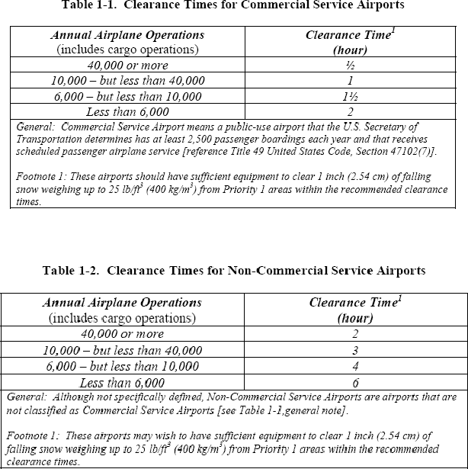

Snow Equipment List.
Can be referenced as an exhibit but provide year, make, model of each piece of snow equipment. Some airports may use primary are secondary equipment.

List Equipment

Storage of Snow and Ice Control Equipment.

Describe where equipment is stored and maintained, inside, inside heated or outside.

Definitions

    - Contaminant. Any substance on a runway, for the purpose of this SICP contaminant is snow, slush, ice or standing water.

    - Dry Snow. Snow that insufficient free water to cause cohesion between individual particles. If when making a snowball, it falls apart, the snow is considered dry.

    - Wet Snow. Snow that has grains coated with liquid water, which bonds the mass together, but that has no excess water in the pore spaces. A well-compacted, solid snowball can be made, but water will not squeeze out.

    - Compacted Snow. Snow that has been compressed into a solid mass that resists further compression and will hold together or break up into lumps if picked up.

    - Slush. Snow that has water content exceeding its freely drained condition, such that it take a fluid properties (.e.g. flowing and splashing). Water will drain from slush when a handful is picked up.
    - Patchy Conditions. Areas of bare pavement showing through snow and/or ice covered pavements.

Chapter 4

Snow Clearing Operations and Ice Prevention

  - Snow Clearing Principals

Ramp and Terminal
a)
Describe snow clearing objective for the ramp and terminal and
who is responsible? (Does your airport contract this area out?)

Address procedures to:
    - Ensure signs are clear of snow Stockpiles of snow issues:
    - Height Limitations-Clearance
    - Obstruct View of Pilots
    - Heavy Snow-Hauling/Melting?

Runway and Taxiways
Describe equipment and procedures used at your airport. Local factors that contribute to these decisions. Minimum acceptable clearing for runway at your airport (is it full width). Typical technique use at your airport.

Types of formation of snow equipment (V-formation, close wing
formation)

High Speed Turn Offs

Snow Bank Height Profiles – See Figure 4-1

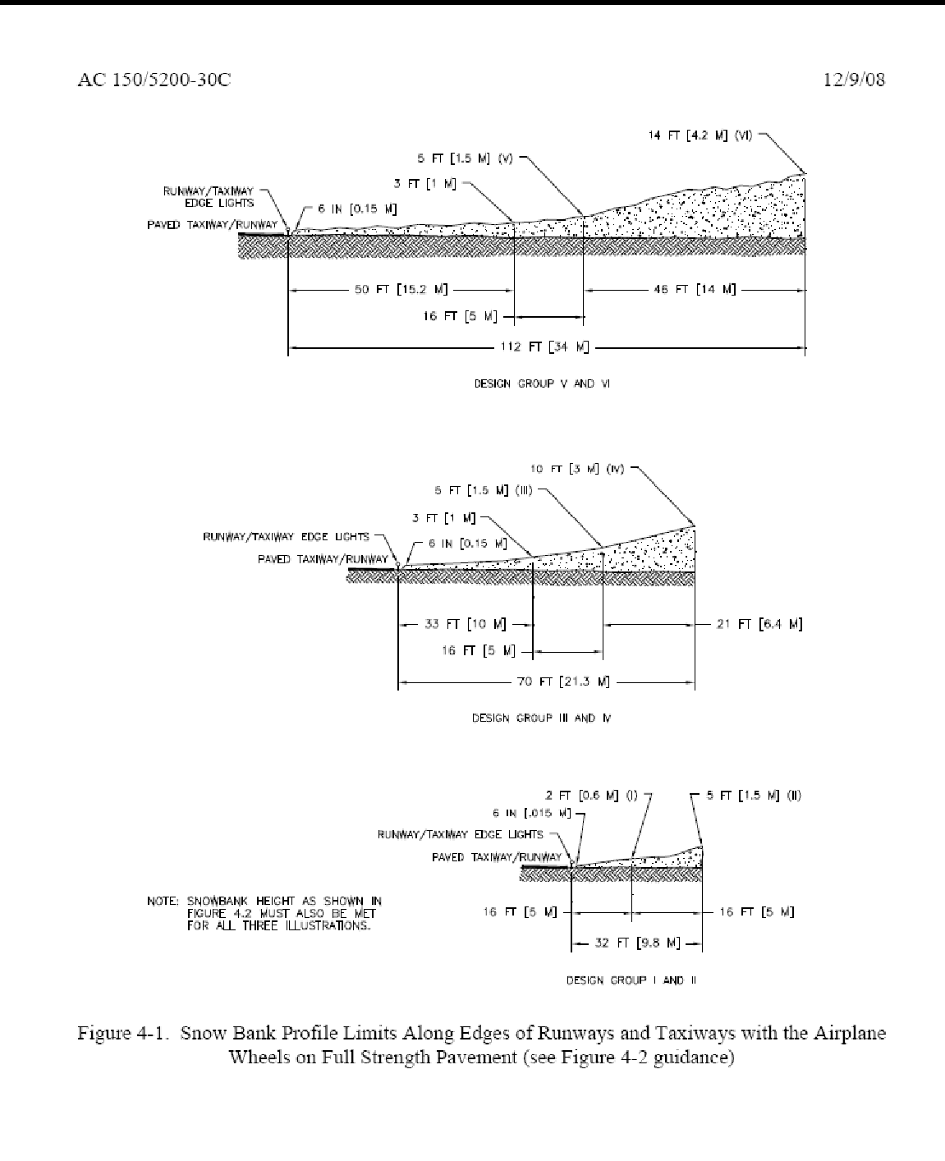

NAVAIDs

Address triggers to clear each glide slope critical areas and PAPI/VASI and who is responsible. Maps describing critical areas.

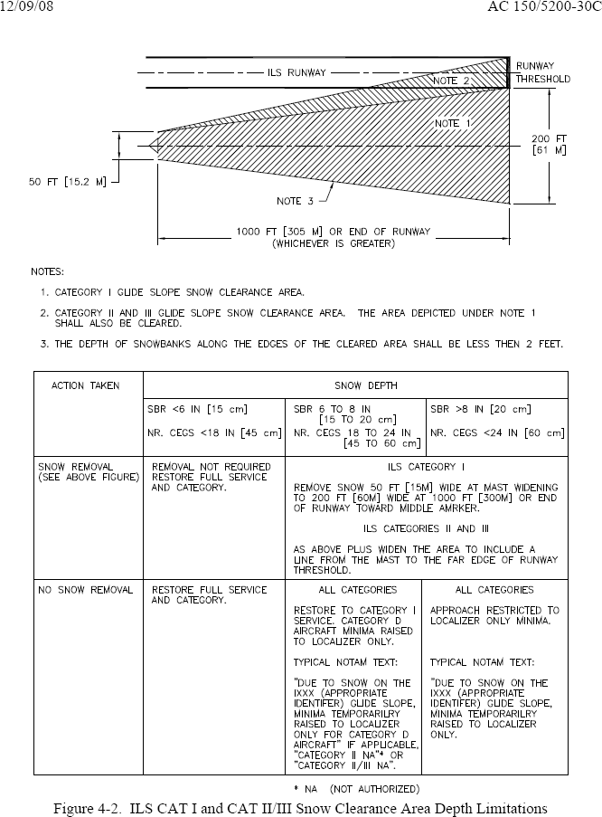

Controlling Snow Drifts

Describe methods used at your airport (i.e. snow fences, snow trenches)

Snow Disposal

Describe how and where large quantities of snow are disposed.

Methods for Ice Control and Removal-Chemicals

Describe if anti-icer or de-icer products are used and which ones and how they are applied.

Sand

Describe if sand is used, how and when it is applied and if it is chemically treated or heated. State if your sand meets FAA gradient standards and which table below.

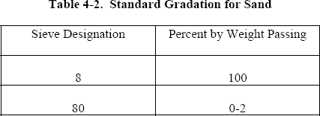

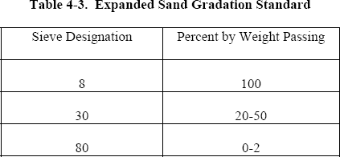

Surface Incident/ Runway Incursion Mitigation Procedures

Do you review past surface incidents at your airport that have occurred during snow removal operations? Do you discuss how additional vehicles and time on the airfield might lead to a surface incident? What preventative measures have you put in place at your airport to prevent such an occurrence during winter operations.

Vehicles will be marked and lighted in accordance with AC 150/2510-5, Painting, Marking and Lighting of Vehicles Used on an Airport.

Radio Communication
How does radio communication work at your airport during Snow Operations? Provide description of your operation, i.e. ground control frequencies, scanner for approach and ground control, CTAF, or be in the direct control of vehicles equipment). Does one person monitor all communication and take the lead on communicating? Are equipment operators provided headsets?

Failed Radio Communication
What procedures do you have in place if radio communication fails between the snow team and or the Air Traffic Control Tower (if applicable)?

Low Visibility and Whiteout Conditions

Describe what specific procedures you have put in place to follow if visibility suddenly drops or a whiteout conditions exist.

Driver Fatigue

Do you have limits on time on equipment or shift? What do you to do for operator fatigue?

Chapter 5

Runway Surface Assessment Reporting

  - Runway Condition Reporting

A runway condition reporting is provided whenever the pavement condition is worse than bare and wet.

Describe procedures for reporting:
    - Runway surface conditions by contaminants types and depths.
    - When the cleared runway width is less than full width, and if you have uncleared runway edges with a different condition from cleared width on runway.

Describe procedures for determining when to update runway conditions. What triggers a runway condition report to be updated or changed (time/changing weather conditions)? Any time a change to the runway surface conditions occurs which could be any of the following:
    - active snow event
    - plowing/brooming/deicing/sanding
    - rapidly rising or falling temperatures
    - rapidly changing conditions

State what the minimum timeline acceptable at your airport when contaminants exist on the runway and runway condition report is updated.

Describe how your airport assesses runway conditions to ensure that they are accurate and timely?

- How often and who is responsible?

- How this information is communicated to the user of your airport and who is responsible to communicate this information?

- What forms are used to convey this information (should be included in you SICP).

If applicable, for small airports:
Issuance of a NOTAM “airfield surface conditions not monitored between the hours of and local time.” Describe the dates this would be in effect for and who would be responsible to issue this NOTAM annually for your airport.

Runway Friction Surveys and Equipment

State what type of equipment (decelerometer or continuous friction measuring equipment) you airport operates. If no friction equipment exists at your airport, state and skip to Paragraph 5.3.

Conditions

Describe what pavement contaminants conditions are acceptable to use decelerometer or continuous friction measuring equipment.

When to Conduct

Friction assessments should be conducted if any of the following occurs:
    - When the central portion of the runway, centered longitudinally along the runway centerline, is contaminated 500 feet or more.
    - After any type of snow removal operations or chemical application (including sanding)
    - Immediately following any aircraft incident or accident on the runway.
    - Describe any additional triggers you have locally.

Friction Measuring Procedures

  - Calibration

Describe how often your friction equipment is calibrated and who is responsible to ensure that it is.

How to Conduct

Describe procedures in how you conduct a friction test and address:

    - lateral location from centerline (provide distance based on narrow or wide body aircraft)

    - direction (same direction as arrival aircraft)

    - friction tests is completed in one pass

    - runway zones, touchdown, midpoint and rollout zones.

Friction Assessment Reporting

Describe procedures at your airport for friction assessment reporting and the format used to report.

Friction values will be reported when:
    - Compacted snow and/or ice are present on the center portion of the runway, and friction values are 40 or below on any zone of the runway.
    - Rise above 40 on all zones of any active runway that previously have a friction value below 40.

Out of Service Equipment

A NOTAM will be issued whenever (specify type of equipment) is out-of- service. This NOTAM will remain until (specify type of equipment) is available for service.

Requirements for Runway Closures

Runways receiving a NIL braking (either a PIREP or by a braking action assessment by the airport operator) are unsafe for aircraft operations. Describe what procedures and Letters of Agreement (include LOA’s) that you have in place to immediately cease all aircraft operations on any runway when a NIL braking action is received.

We recommend some airports develop additional triggers for runway closures (i.e. maximum slush, wet, dry snow depths, ice or freezing rain and minimum MU level).

If you have several triggers requiring runway closures, the format of a table might be beneficial.

Continuous Monitoring

Describe when continuous monitoring procedures are put in place and what deteriorating braking action, weather and surface conditions triggers continuous monitoring. What constitutes continuously monitoring a runway at your airport (details)?

